**Mfrs: Shredder machines | Dewatering machines | Conveyors | Wire strippers | Reverse Vending Machines**

|  |
| --- |
| **ORBIT MACHINES**  **Sales Quotation**  **S.F No .458,Door No.47, Maruthamalai Gounder Layout,**  **R.K Puram, Sathy Road, Ganapathy,**  **Coimbatore - Tamil Nadu, India Pin: 641006**  **Date: Nov 30, 2021**  **Quotation No: 624-A/QTN/OM/2021-2022/1**  no:  **balasuresh34@gmail.com**  **Mob: 07971272680**  **www.orbitmachines.in**  **TIN: 33822104104 | GSTIN: 33BSVPB7613LIZE** |

|  |  |
| --- | --- |
| **TO:**  **MR. parry agro,**  **47,maruathamalaigounder layout**  **ganapthy**  **coimbatore Pin: 641006**  **9952566615**  **balasuresh@gmail.com** | **Ref Person: Mr. parry agro**  **Contact no: 9952566615** |

**Thank you for your inquiry dated:**

**We are pleased to quote you the following:**

**We are pleased to quote you the following:**

|  |
| --- |
|  |
| |  |  |  |  | | --- | --- | --- | --- | | **S.No.** | **Image** | **Description** | **Unit Price + GST** | | 01 |  | **shredder**  **WOOD CHIPPER CUM PULVERIZER-100 HP**   * **POWER  - 100HP 3PHASE** * **FINAL PARTICLE SIZE – BELOW 15 MM** * **OVER SIZE CHIPS : 2-5 %** * **MATERIAL : MS** * **BLADE CUTTING MATERIAL : SPECIAL ALLOY STEEL** * **ROTATING BLADES: 4  NOS** * **HAMMER BLADES : 24 NOS** * **NO OF BLADES  STATIONARY:3 NO** * **FEED OPENING : 300 X 300MM** * **FEEDING MATERIAL SIZE : 1.5 -8 INCHES** * **WORKING AREA: 950 X 300 MM** * **SHREDDING CAPACITY : 3-5 TON / HR**   **(SUBJECTED TO FIRE WOOD FEEDING EFFICIENCY AND MOISTURE WITH 30-40%)**   * **MACHINE SIZE :2000 X 1400 X 1500mm   LXBXH** * **DRIVE: V-BELT DRIVE** * **SPARES: 1 SET** * **MACHINE WEIGHT : 3200  KG(APPROX)** * **FINISHING : PAINTING** * **2hp motor  tool grinder for blade sharpness**   **APPLICATION: WOOD LOG** | 23500.00 GST 18% 4230.00 | |  |  | **Sub Total Inclusive GST 18%** | **235000.00** | |  |  | **Total** | **235000** |  | **S. NO** | **PRODUCT NAME** | **UNIT PRICE + GST** | | --- | --- | --- | | 01 | shredder | 23500.00 | |  | Inclusive GST 18% | 235000.00 | |
|  |
|  |

Orbit Machines– Industrial & Recycling Machines Manufacturer

**Orbit** stands out in terms of experience and expertise when it comes to crushing, shredding, and dewatering equipment. We are able to offer complete crushing, shredding, conveying, wire stripping, and dewatering systems.

**We will be happy to supply any further information you may need and trust that you call on us to fill your order, which will receive our prompt and careful attention.**

**Terms & Conditions**

**Tax : GST 18%**

**PACKING & FORWAD : Ex-works, Coimbatore**

**PAYMENT : 50% Advance, Balance Against material dispatch**

**VALIDITY OFFER : 15 Days**

**DELIVERY : material will be dispatched within 30 to**

**35 working days from advance payment**

**WARRANTY : 1 year machine warranty from the invoice date.**

**INSTLATION &**

**COMMISSIONING : Travelling and accommodation will be at your scope**

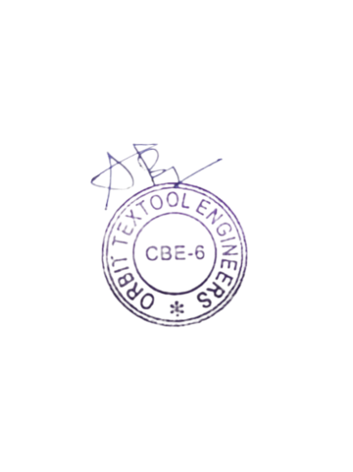

**Authorized Signature**